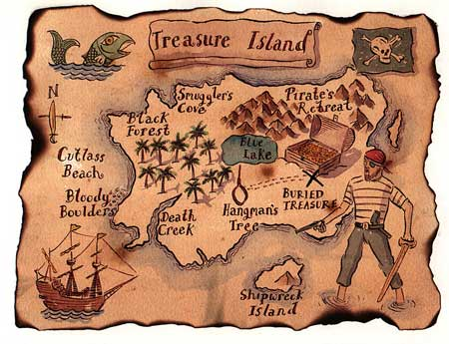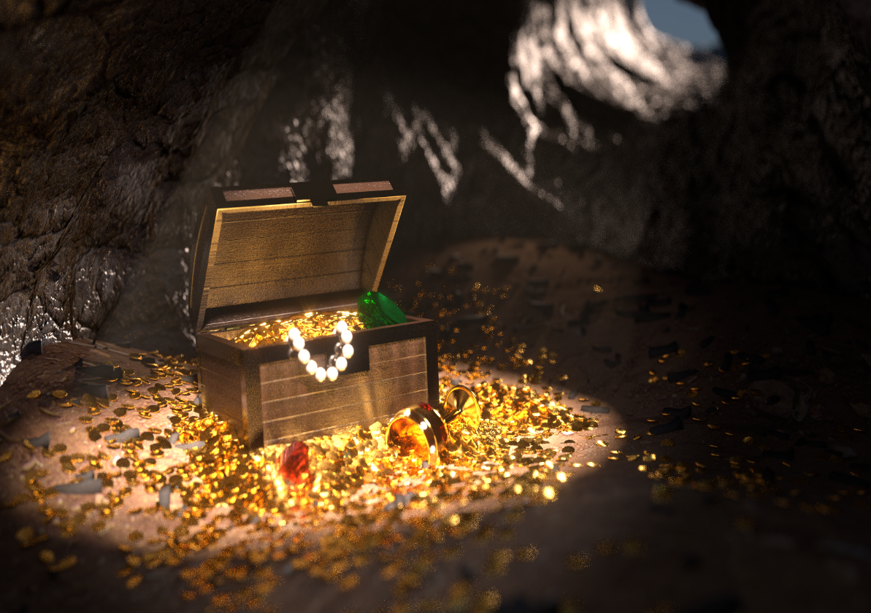

Come Spend a Night on Treasure Island

FOOD, DRINKS, RAFFLE PRIZES and lots of give a ways

MUSIC AND PHOTO BOOTH

Prizes for best costumes

Thursday night

9:00pm to 11:00 pm

Merrill Hall